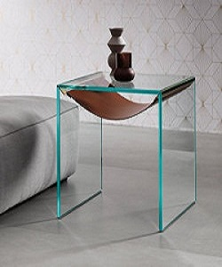

Simple End table/Coffee table

$32.67

Availability: In stock

Description:

End table or bedside table unit with a structure in extra-clear glass. The distinctive feature is an elegant shelf element available in cowhide or fabric, with metal supports that can be personalized in stainless steel, brass or copper.